**PRACTICAL NO : 1**

**Data Pre-processing and Exploration**

**Aim:[A] Load a CSV dataset. Handle missing values, inconsistent formatting, and outliers.**

**CODE:**

#Import necessary libraries

import pandas as pd

import numpy as np

from sklearn.impute import SimpleImputer

from sklearn.preprocessing import StandardScaler

#Load the CSV dataset

df = pd.read_csv('C:\\Users\\Lenovo\\Desktop\\MSC IT PROGRAM - Poornima\\SEM 3\\ML\\PRACTIAL 1 DATASETS.csv')

#Check for missing values

# Show the count of missing values in each column

print(df.isnull().sum())

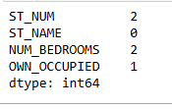

df = df.dropna() # Removes all rows with missing data

# Impute missing numerical values with the mean

imputer = SimpleImputer(strategy='mean')

df['ST_NUM'] = imputer.fit_transform(df[['ST_NUM']])

# Fill categorical missing values with mode (most frequent value)

df['OWN_OCCUPIED'].fillna(df['OWN_OCCUPIED'].mode()[0], inplace=True)

df['OWN_OCCUPIED'] = df['OWN_OCCUPIED'].str.strip()

df['OWN_OCCUPIED'] = df['OWN_OCCUPIED'].str.lower()

from scipy import stats

# Compute Z-scores and remove data points with Z-scores > 3 or < -3

z_scores = np.abs(stats.zscore(df['ST_NUM']))

df = df[(z_scores < 3)]

Q1 = df['ST_NUM'].quantile(0.25)

Q3 = df['ST_NUM'].quantile(0.75)

IQR = Q3 - Q1

# Remove rows that have outliers (data points outside 1.5 times the IQR)

df = df[~((df['ST_NUM'] < (Q1 - 1.5 * IQR)) | (df['ST_NUM'] > (Q3 + 1.5 * IQR)))]

scaler = StandardScaler()

df['ST_NUM'] = scaler.fit_transform(df[['ST_NUM']])

df.to_csv('cleaned_dataset.csv', index=False)

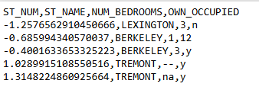

**Aim:[B] Load a dataset, calculate descriptive summary statistics, create visualizations using different graphs, and identify potential features and target variables**

**CODE:**

import pandas as pd

import numpy as np

import matplotlib.pyplot as plt

import seaborn as sns

# Load dataset (replace 'your_dataset.csv' with your file path)

df = pd.read_csv("C:\\Users\\Lenovo\\Desktop\\MSC IT PROGRAM - Poornima\\SEM 3\\ML\\PRACTIAL 1 ML\\cleaned_dataset.csv")

# Descriptive statistics for numerical columns

print(df.describe())

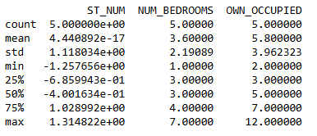

# Descriptive statistics for categorical columns

print(df.describe(include='object'))

# Checking for unique values in each column

print(df.nunique())

# Checking for missing values in the dataset

print(df.isnull().sum())

# ⦁ Histogram (for numerical data):

plt.figure(figsize=(8, 6))

df['ST_NUM'].hist(bins=30)

plt.title('Distribution of Numeric Column')

plt.xlabel('Values')

plt.ylabel('Frequency')

plt.show()

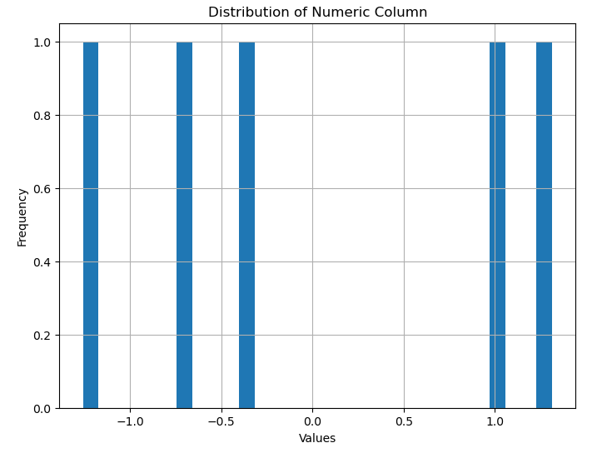

# ⦁ Boxplot (for detecting outliers):

plt.figure(figsize=(8, 6))

sns.boxplot(x=df['NUM_BEDROOMS'])

plt.title('Boxplot of Numeric Column')

plt.show()

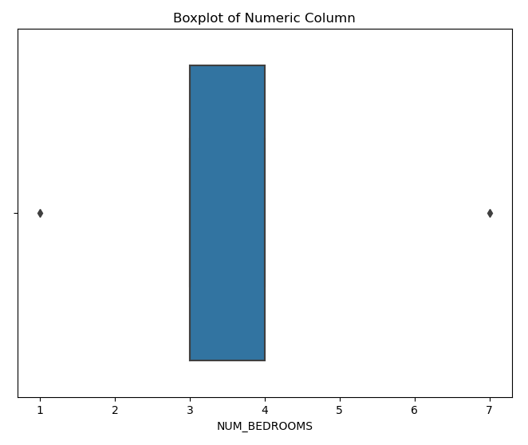

# ⦁ Count plot (for categorical variables):

plt.figure(figsize=(8, 6))

sns.countplot(x=df['ST_NUM'])

plt.title('Count of Categorical Column')

plt.show()

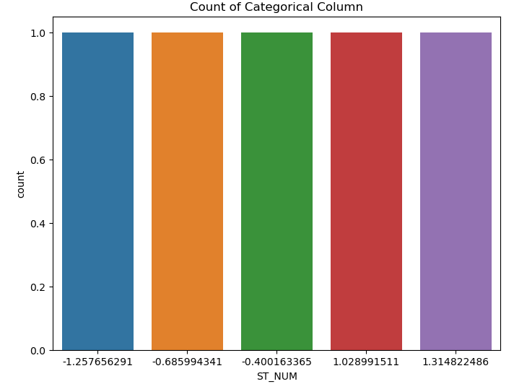

# Scatter Plot

plt.figure(figsize=(8, 6))

plt.scatter(df['ST_NUM'], df['NUM_BEDROOMS'])

plt.title('Scatter Plot of ST_NUM vs NUM_BEDROOMS')

plt.xlabel('ST_NUM')

plt.ylabel('NUM_BEDROOMS')

plt.show()

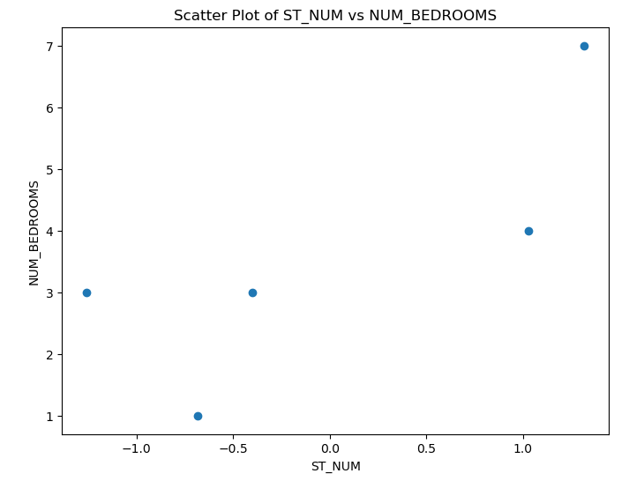  
# Pairplot (with categorical hue)

sns.pairplot(df[['ST_NUM', 'NUM_BEDROOMS', 'OWN_OCCUPIED']], hue='OWN_OCCUPIED')

plt.show()

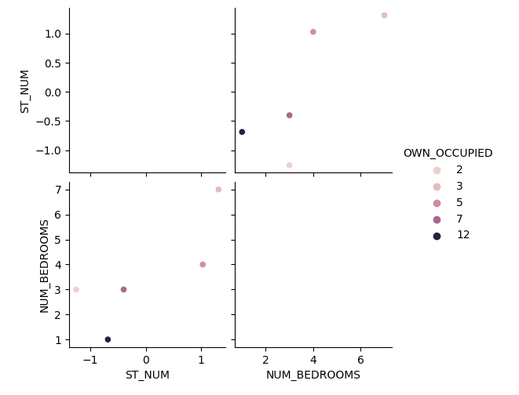

# Correlation Heatmap (excluding non-numeric columns)

plt.figure(figsize=(10, 8))

# Select only numeric columns for the correlation calculation

numeric_df = df.select_dtypes(include=[float, int])

correlation_matrix = numeric_df.corr()

# Correlation with target column

correlation = df.corr()['OWN_OCCUPIED'].sort_values(ascending=False)

print(correlation)

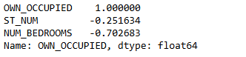

plt.figure(figsize=(8, 6))

sns.boxplot(x=df['ST_NUM'])

plt.title('Boxplot of Numeric Column')

plt.savefig('boxplot.png')

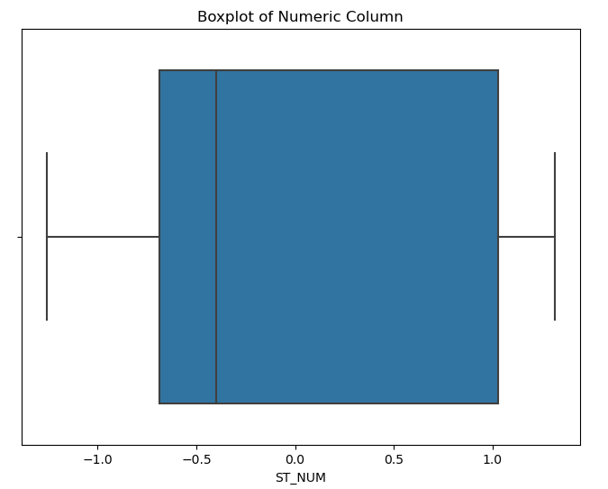

**Aim:[C] Create or Explore datasets to use all pre-processing routines like label encoding, scaling, and binarization.**

**CODE:**

import pandas as pd

import numpy as np

from sklearn.preprocessing import LabelEncoder, StandardScaler, MinMaxScaler, Binarizer

# Create a sample dataset

data = {

'Age': [22, 25, 47, 52, 46, 56, 36],

'Salary': [21000, 25000, 47000, 52000, 46000, 56000, 36000],

'City': ['New York', 'Paris', 'Berlin', 'New York', 'Berlin', 'Paris', 'Berlin'],

'Purchased': ['Yes', 'No', 'Yes', 'No', 'Yes', 'No', 'Yes']

}

# Convert into a pandas DataFrame

df = pd.DataFrame(data)

print(df)

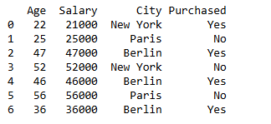

# Initialize the label encoder

label_encoder = LabelEncoder()

# Encode the 'City' column

df['City_encoded'] = label_encoder.fit_transform(df['City'])

print(df[['City', 'City_encoded']])

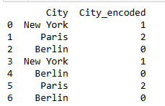

df['Purchased_encoded'] = label_encoder.fit_transform(df['Purchased'])

print(df[['Purchased', 'Purchased_encoded']])

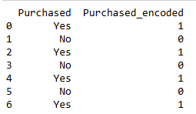

# Initialize the standard scaler

scaler = StandardScaler()

# Apply scaling to 'Age' and 'Salary' columns

df[['Age_scaled', 'Salary_scaled']] = scaler.fit_transform(df[['Age', 'Salary']])

print(df[['Age', 'Age_scaled', 'Salary', 'Salary_scaled']])

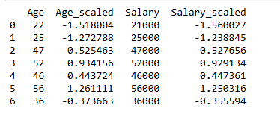

# Initialize the MinMaxScaler

minmax_scaler = MinMaxScaler()

# Apply scaling to 'Age' and 'Salary'

df[['Age_minmax', 'Salary_minmax']] = minmax_scaler.fit_transform(df[['Age', 'Salary']])

print(df[['Age', 'Age_minmax', 'Salary', 'Salary_minmax']])

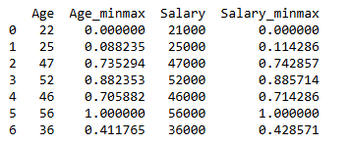

# Initialize the binarizer

binarizer = Binarizer(threshold=40)

# Apply binarization to 'Age'

df['Age_binarized'] = binarizer.fit_transform(df[['Age']])

print(df[['Age', 'Age_binarized']])

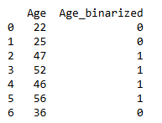

print(df)

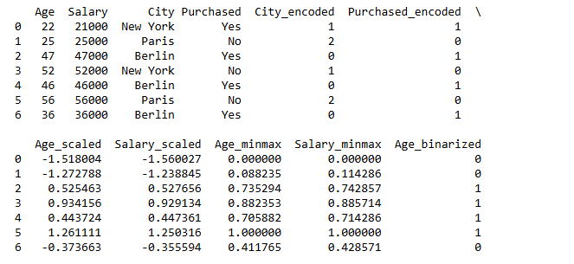

**PRACTICAL NO : 2**

**Testing Hypothesis**

**Aim:[A] Implement and demonstrate the FIND-S algorithm for finding the most specific hypothesis based on a given set of training data samples. Read the training data from a. CSV file and generate the final specific hypothesis. (Create your dataset)**

**CODE:**

import csv

num_attributes = 6 # We have 6 attributes excluding the class

a = []

print("\nThe Given Training Dataset \n")

with open("Book1.csv", "r") as csvfile:

reader = csv.reader(csvfile)

count = 0

for row in reader:

if count == 0:

print(row)

count += 1

else:

a.append(row)

print(row)

count += 1

print("\nThe initial value of hypothesis: ")

hypothesis = ["0"] * num_attributes # Initialize hypothesis with placeholders

print(hypothesis)

# Set the hypothesis to the first row (excluding class)

for j in range(0, num_attributes):

hypothesis[j] = a[0][j]

print(hypothesis)

print("\nFind S: Finding a Maximally Specific Hypothesis\n")

for i in range(0, len(a)):

if a[i][num_attributes] == "Yes": # Check if the class label is 'Yes'

for j in range(0, num_attributes):

if a[i][j] != hypothesis[j]: # If the attribute doesn't match, set to '?'

hypothesis[j] = "?"

print(f"for training example no:{i} the hypothesis is {hypothesis}")

print(hypothesis)

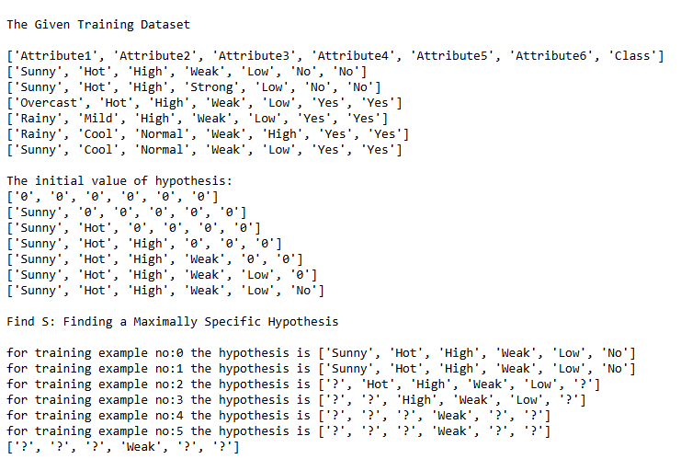

**PRACTICAL NO : 3**

**Linear Models**

**Aim:[A] Simple Linear Regression**

**Fit a linear regression model on a dataset. Interpret coefficients, make predictions, and evaluate performance using metrics like R-squared and MSE**

**CODE:**

import numpy as np

import pandas as pd

import matplotlib.pyplot as plt

from sklearn.linear_model import LinearRegression

from sklearn.metrics import mean_squared_error, r2_score

np.random.seed(0)

X = np.random.rand(100,1)

y = 20 * X + 1 + np.random.randn(100, 1)

data = pd.DataFrame({'X': X.flatten(), 'y': y.flatten()})

plt.scatter(X , y)

plt.xlabel('Independent Variable (X)')

plt.ylabel('Dependent Variable (y)')

plt.title('Sample Data for linear regression')

plt.show()

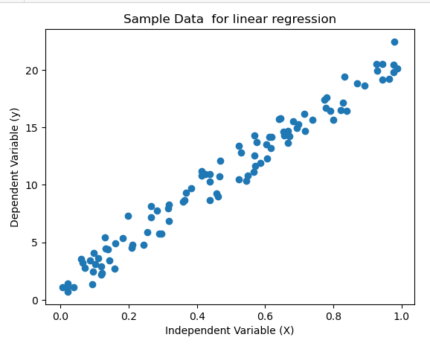

from sklearn.model_selection import train_test_split

X_train, X_test, y_train, y_test = train_test_split(X, y, test_size = 0.2, random_state= 42 )

model = LinearRegression()

model.fit(X_train, y_train)

y_pred = model.predict(X_test)

mse = mean_squared_error(y_test, y_pred)

r_squared = r2_score(y_test, y_pred)

print(f'Mean square error (mse): {mse:.2f}')

print(f'R squared(r): {r_squared:.2f}')



plt.scatter(X, y, label='Data')

plt.plot(X_test, y_pred, color='red', linewidth = 2, label= 'Regression Line')

plt.xlabel('Independent Variable (X)')

plt.ylabel('Dependent Variable (y)')

plt.title('linear regression model')

plt.legend()

plt.show()

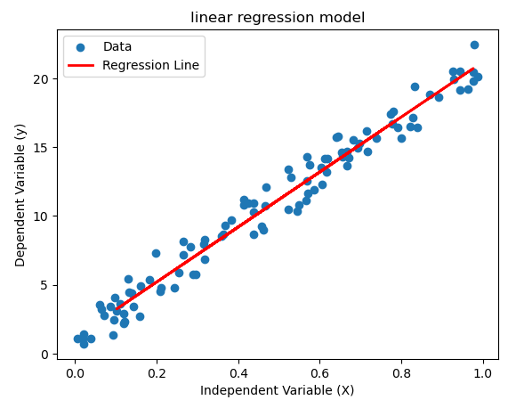

coefficients = model.coef_

intercept = model.intercept_

print(f'coefficients: {coefficients[0][0]:.2f}')

print(f'intercept: {intercept[0]:.2f}')



**Aim:[B] Multiple Linear Regression**

**Extend linear regression to multiple features. Handle feature selection and potential multicollinearity.**

**CODE:**

import numpy as np

import pandas as pd

import matplotlib.pyplot as plt

import seaborn as sns

from sklearn.linear_model import LinearRegression

from sklearn.metrics import mean_squared_error, r2_score

from sklearn.model_selection import train_test_split

from sklearn.preprocessing import StandardScaler

from statsmodels.stats.outliers_influence import variance_inflation_factor

from sklearn.decomposition import PCA

# Synthetic data generation

np.random.seed(0)

X1 = np.random.rand(100, 1) # Feature 1

X2 = 2 * X1 + np.random.randn(100, 1) * 0.1 # Feature 2 (correlated with X1)

X3 = np.random.rand(100, 1) # Feature 3 (independent)

y = 10 * X1 + 5 * X2 + 3 * X3 + np.random.randn(100, 1) # Target variable with noise

# Combine features into a DataFrame

X = np.hstack([X1, X2, X3])

data = pd.DataFrame(X, columns=['X1', 'X2', 'X3'])

data['y'] = y

# Check multicollinearity using VIF

scaler = StandardScaler()

X_scaled = scaler.fit_transform(X)

vif_data = pd.DataFrame({

"Feature": ['X1', 'X2', 'X3'],

"VIF": [variance_inflation_factor(X_scaled, i) for i in range(X_scaled.shape[1])]

})

print("Variance Inflation Factor (VIF):\n", vif_data)

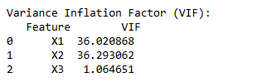

# Visualize correlation

corr = pd.DataFrame(X, columns=['X1', 'X2', 'X3']).corr()

sns.heatmap(corr, annot=True, cmap="coolwarm")

plt.title("Correlation Heatmap")

plt.show()

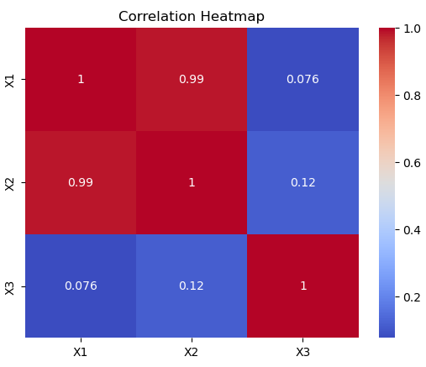

# Address multicollinearity with PCA if necessary

pca = PCA(n_components=2) # Reduce to 2 components

X_pca = pca.fit_transform(X_scaled)

# Train-test split

X_train, X_test, y_train, y_test = train_test_split(X, y, test_size=0.2, random_state=42)

X_train_pca, X_test_pca, y_train, y_test = train_test_split(X_pca, y, test_size=0.2, random_state=42)

# Fit and evaluate model without PCA

model = LinearRegression()

model.fit(X_train, y_train)

y_pred = model.predict(X_test)

print(f"\nModel Without PCA: MSE = {mean_squared_error(y_test, y_pred):.2f}, R^2 = {r2_score(y_test, y_pred):.2f}")

# Fit and evaluate model with PCA

model_pca = LinearRegression()

model_pca.fit(X_train_pca, y_train)

y_pred_pca = model_pca.predict(X_test_pca)

print(f"\nModel With PCA: MSE = {mean_squared_error(y_test, y_pred_pca):.2f}, R^2 = {r2_score(y_test, y_pred_pca):.2f}")

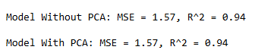

# Visualization of predictions

plt.scatter(y_test, y_pred, label='Without PCA', alpha=0.7)

plt.scatter(y_test, y_pred_pca, label='With PCA', alpha=0.7)

plt.plot([y_test.min(), y_test.max()], [y_test.min(), y_test.max()], color='red', linestyle='--', linewidth=2)

plt.xlabel('Actual Values')

plt.ylabel('Predicted Values')

plt.title('Actual vs Predicted Values')

plt.legend()

plt.show()

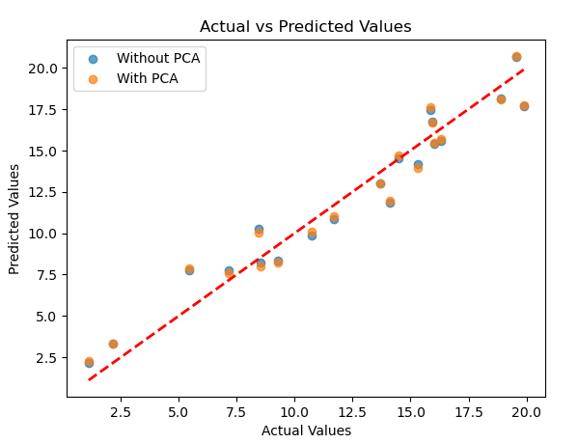

**Aim:[C] Regularized Linear Models**

**Implement regression variants like LASSO and Ridge on any generated dataset.**

**CODE:**

import pandas as pd

import numpy as np

import matplotlib.pyplot as plt

from sklearn.datasets import fetch_california_housing

from sklearn.model_selection import train_test_split

from sklearn.linear_model import LinearRegression

# Loading California Housing Dataset

california_dataset = fetch_california_housing()

# Display the dataset description

print(california_dataset.DESCR)

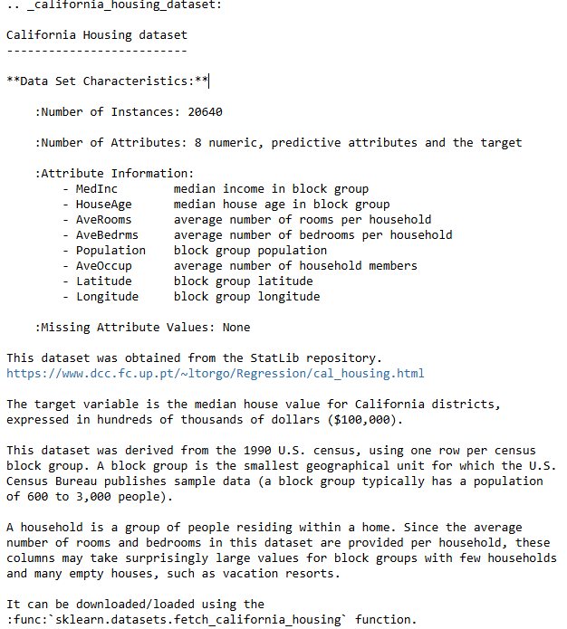

# Convert the dataset into a Pandas DataFrame

california_df = pd.DataFrame(california_dataset.data, columns=california_dataset.feature_names)

# Add the target variable (House Price) to the DataFrame

california_df['House Price'] = california_dataset.target

# Display the first few rows of the dataset

print(california_df.head())

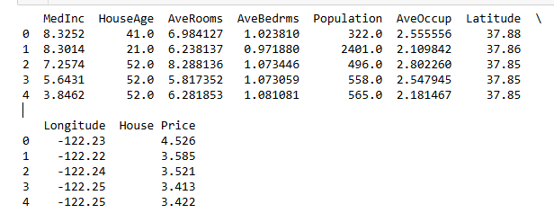

# Split the data into input (X) and output (y)

X = california_df.iloc[:, :-1] # All columns except the target

y = california_df.iloc[:, -1] # Target variable (House Price)

# Split the data into training and testing sets (75% for training, 25% for testing)

X_train, X_test, y_train, y_test = train_test_split(X, y, test_size=0.25, random_state=42)

print(f"Training data shape: X = {X_train.shape}, y = {y_train.shape}")

print(f"Testing data shape: X = {X_test.shape}, y = {y_test.shape}")



# Create and train the linear regression model

lr_model = LinearRegression()

lr_model.fit(X_train, y_train)

# Make predictions on the test set

y_pred = lr_model.predict(X_test)

# Calculate Mean Squared Error

mse = np.mean((y_pred - y_test) ** 2)

print(f"Mean Squared Error: {mse}")

# Display the coefficients

coefficients = pd.DataFrame()

coefficients['Feature'] = X_train.columns

coefficients['Coefficient Estimate'] = lr_model.coef_

print(coefficients)

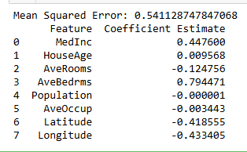

# Plotting the coefficient scores

fig, ax = plt.subplots(figsize=(10, 6))

ax.bar(coefficients['Feature'], coefficients['Coefficient Estimate'])

ax.set_xlabel('Features')

ax.set_ylabel('Coefficient Estimate')

plt.xticks(rotation=90)

plt.show()

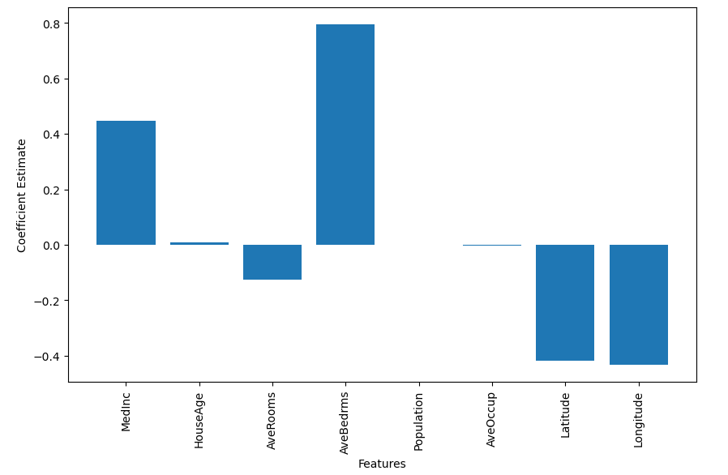

# Ridge Regression

from sklearn.linear_model import Ridge

ridge_model = Ridge(alpha=1)

ridge_model.fit(X_train, y_train)

ridge_pred = ridge_model.predict(X_test)

ridge_mse = np.mean((ridge_pred - y_test) ** 2)

print(f"Ridge Regression MSE: {ridge_mse}")



#Lasso

from sklearn.linear_model import Lasso

lasso_model = Ridge(alpha=1)

lasso_model.fit(X_train, y_train)

lasso_pred = Lasso_model.predict(X_test)

lasso_mse = np.mean((lasso_pred - y_test) ** 2)

print(f"Lasso Regression MSE: {lasso_mse}")



#ElasticNet

from sklearn.linear_model import ElasticNet

ElasticNet_model = ElasticNet(alpha=1)

ElasticNet_model.fit(X_train, y_train)

ElasticNet_pred = ElasticNet_model.predict(X_test)

ElasticNet_mse = np.mean((ElasticNet_pred - y_test) ** 2)

print(f"ElasticNet Regression MSE: {ElasticNet_mse}")



**PRACTICAL NO : 4**

**Discriminative Models**

**Aim:[A] Logistic Regression**

**Perform binary classification using logistic regression. Calculate accuracy, precision, recall, and understand the ROC curve.**

**CODE:**

import matplotlib.pyplot as plt

from sklearn.datasets import make_classification

from sklearn.model_selection import train_test_split

from sklearn.linear_model import LogisticRegression

from sklearn.metrics import precision_recall_curve, auc

# Generate a synthetic dataset

X, y = make_classification(

n_samples=1000, n_features=20, n_classes=2, random_state=42)

# Split the dataset into training and testing sets

X_train, X_test, y_train, y_test = train_test_split(

X, y, test_size=0.2, random_state=42)

# Train a logistic regression model (you can replace this with your own classifier)

model = LogisticRegression()

model.fit(X_train, y_train)

# Predict probabilities for positive class

y_scores = model.predict_proba(X_test)[:, 1]

# Calculate precision and recall

precision, recall, thresholds = precision_recall_curve(y_test, y_scores)

# Calculate Area Under the Curve (AUC) for precision-recall curve

auc_score = auc(recall, precision)

# Plot precision-recall curve

plt.figure(figsize=(8, 6))

plt.plot(recall, precision, label=f'Precision-Recall Curve (AUC = {auc_score:.2f})')

plt.xlabel('Recall')

plt.ylabel('Precision')

plt.title('Precision-Recall Curve')

plt.legend()

plt.show()

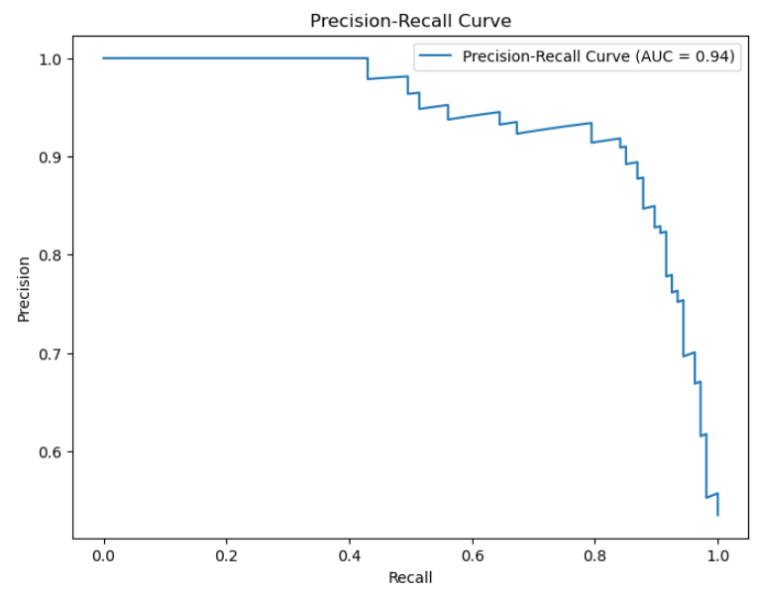

from sklearn.metrics import accuracy_score

# Predict class labels

y_pred = model.predict(X_test)

# Calculate accuracy

accuracy = accuracy_score(y_test, y_pred)

print(f'Accuracy: {accuracy:.2f}')



from sklearn.metrics import roc_curve, roc_auc_score

# Compute ROC curve

fpr, tpr, _ = roc_curve(y_test, y_scores)

# Compute AUC for ROC curve

roc_auc = roc_auc_score(y_test, y_scores)

# Plot ROC curve

plt.figure(figsize=(8, 6))

plt.plot(fpr, tpr, label=f'ROC Curve (AUC = {roc_auc:.2f})')

plt.plot([0, 1], [0, 1], linestyle='--', color='gray') # Random guess line

plt.xlabel('False Positive Rate')

plt.ylabel('True Positive Rate')

plt.title('Receiver Operating Characteristic (ROC) Curve')

plt.legend()

plt.show()

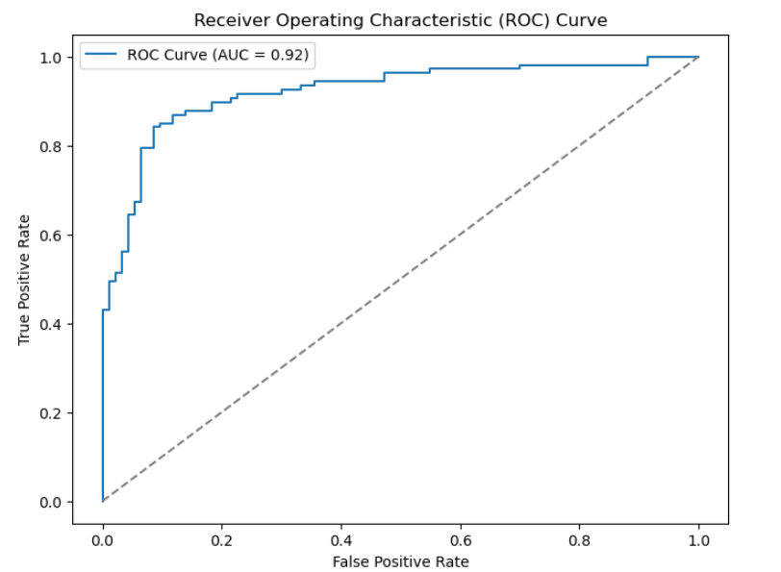

**Aim:[B]**

**Implement and demonstrate k-nearest Neighbor algorithm. Read the training data from a .CSV file and build the model to classify a test sample. Print both correct and wrong predictions.**

**CODE:**

pip install --upgrade numpy

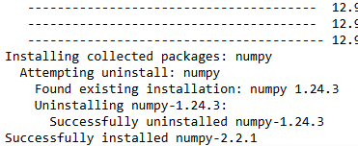

pip install --upgrade scikit-learn



import pandas as pd

from sklearn.model_selection import train_test_split

from sklearn.neighbors import KNeighborsClassifier

from sklearn.metrics import accuracy_score

from sklearn.preprocessing import LabelEncoder

# Load the Iris dataset from CSV file

data = pd.read_csv('iris.csv')

# Convert 'species' column to numeric values

label_encoder = LabelEncoder()

data['label'] = label_encoder.fit_transform(data['species']) # Use 'species' for LabelEncoder

# Define features (X) and target (y)

X = data.iloc[:, :-2].values # Exclude the last column (label) and 'species' column

y = data['label'].values # Use the 'label' column for targets

# Split the data into training and testing sets

X_train, X_test, y_train, y_test = train_test_split(X, y, test_size=0.2, random_state=42)

# Print the sizes of train and test sets

print(f'Training samples: {X_train.shape[0]}')

print(f'Test samples: {X_test.shape[0]}')

# Initialize the K-Nearest Neighbors classifier with n_neighbors=4

knn = KNeighborsClassifier(n_neighbors=10)

# Train the model

knn.fit(X_train, y_train)

# Predict on the test set

y_pred = knn.predict(X_test)

# Calculate accuracy

accuracy = accuracy_score(y_test, y_pred)

print(f'Accuracy: {accuracy:.2f}')

# Print correct and wrong predictions

correct_predictions = [(x, y_true, y_pred) for x, y_true, y_pred in zip(X_test, y_test, y_pred) if y_true == y_pred]

wrong_predictions = [(x, y_true, y_pred) for x, y_true, y_pred in zip(X_test, y_test, y_pred) if y_true != y_pred]

# Print correct predictions

print("\nCorrect Predictions:")

for sample, true_label, pred_label in correct_predictions:

print(f"Sample: {sample}, True: {true_label}, Predicted: {pred_label}")

# Print wrong predictions

print("\nWrong Predictions:")

for sample, true_label, pred_label in wrong_predictions:

print(f"Sample: {sample}, True: {true_label}, Predicted: {pred_label}")

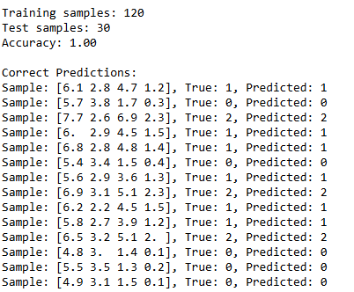

from sklearn.model_selection import cross_val_score

# Perform 5-fold cross-validation

cv_scores = cross_val_score(knn, X, y, cv=5)

# Print the cross-validation scores

print(f'Cross-validation scores: {cv_scores}')

print(f'Mean cross-validation score: {cv_scores.mean():.2f}')



**Aim:[C]**

**Build a decision tree classifier or regressor. Control hyperparameters like tree depth to avoid overfitting. Visualize the tree.**

**CODE:**

import pandas as pd

from sklearn.model_selection import train_test_split

from sklearn.tree import DecisionTreeClassifier, plot_tree

from sklearn.metrics import accuracy_score

import matplotlib.pyplot as plt

from sklearn.preprocessing import LabelEncoder

# Load the dataset

data = pd.read_csv('iris.csv')

# Convert 'species' column to numeric values

label_encoder = LabelEncoder()

data['species'] = label_encoder.fit_transform(data['species'])

# Define features (X) and target (y)

X = data.iloc[:, :-1].values # Features

y = data.iloc[:, -1].values # Target

# Split the data into training and testing sets

X_train, X_test, y_train, y_test = train_test_split(X, y, test_size=0.2, random_state=42)

# Try adjusting the depth and other parameters

tree = DecisionTreeClassifier(max_depth=3, min_samples_split=4, min_samples_leaf=2, random_state=42)

tree.fit(X_train, y_train)

# Visualize the tree

plt.figure(figsize=(12, 8))

plot_tree(tree, filled=True, feature_names=data.columns[:-1], class_names=label_encoder.classes_, rounded=True)

plt.title('Decision Tree Classifier')

plt.show()

# Check accuracy again

y_pred = tree.predict(X_test)

accuracy = accuracy_score(y_test, y_pred)

print(f'Accuracy: {accuracy:.2f}')

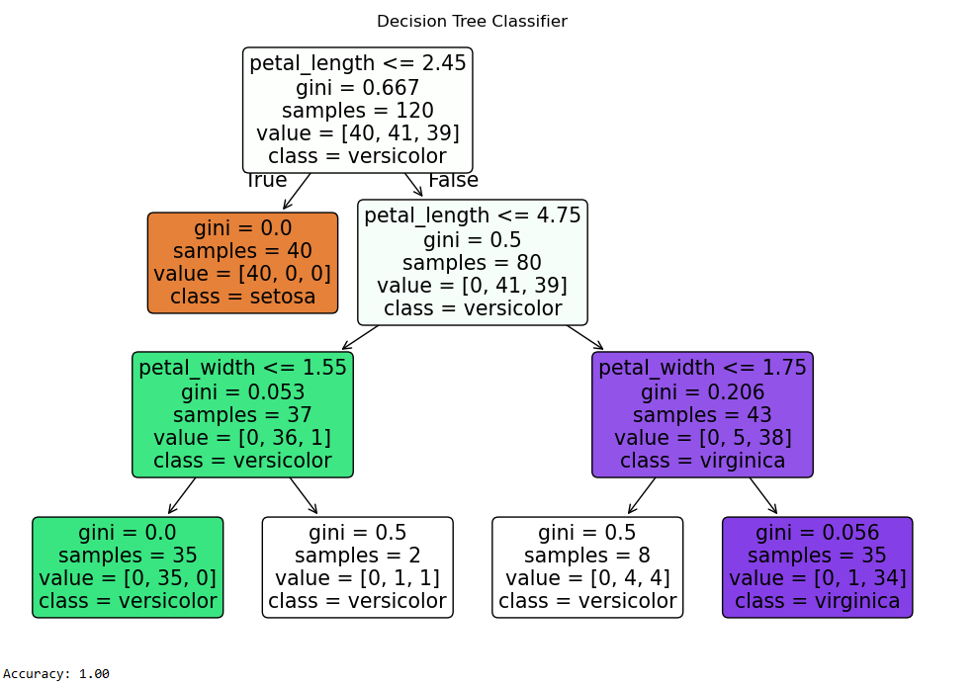

**Aim:[D]**

**Implement a Support Vector Machine for any relevant dataset.**

**CODE:**

import pandas as pd

from sklearn.model_selection import train_test_split

from sklearn.svm import SVC

from sklearn.metrics import accuracy_score

from sklearn.preprocessing import LabelEncoder

# Load the Iris dataset from CSV file

data = pd.read_csv('iris.csv')

# Convert the 'species' column to numeric values using LabelEncoder

label_encoder = LabelEncoder()

data['label'] = label_encoder.fit_transform(data['species'])

# Ensure the features are numeric and the 'species' column is removed

# Features: sepal_length, sepal_width, petal_length, petal_width

X = data[['sepal_length', 'sepal_width', 'petal_length', 'petal_width']].values

y = data['label'].values # Target: species (encoded labels)

# Double-check that X contains only numeric values

print("Features (X):")

print(X[:5]) # Print the first 5 rows of X

# Split the data into training and testing sets

X_train, X_test, y_train, y_test = train_test_split(X, y, test_size=0.2, random_state=42)

# Initialize the Support Vector Machine (SVM) model

svm_model = SVC(kernel='linear', random_state=42) # Using a linear kernel

# Train the SVM model on the training data

svm_model.fit(X_train, y_train)

# Predict the labels on the test set

y_pred = svm_model.predict(X_test)

# Calculate and print the accuracy of the model

accuracy = accuracy_score(y_test, y_pred)

print(f'Accuracy: {accuracy:.2f}')

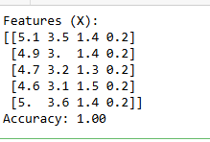

from sklearn.metrics import confusion_matrix, classification_report

# Confusion Matrix

cm = confusion_matrix(y_test, y_pred)

print("Confusion Matrix:\n", cm)

# Classification Report

cr = classification_report(y_test, y_pred)

print("Classification Report:\n", cr)

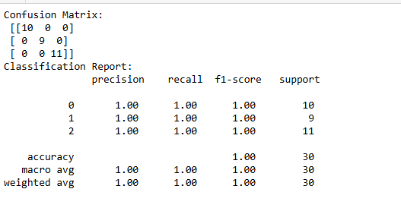

from sklearn.model_selection import cross_val_score

cross_val_scores = cross_val_score(svm_model, X, y, cv=5)

print(f"Cross-validation scores: {cross_val_scores}")

print(f"Mean cross-validation score: {cross_val_scores.mean()}")



import numpy as np

import matplotlib.pyplot as plt

# Use only the first two features for visualization (e.g., sepal length and sepal width)

X_train_2d = X_train[:, :2]

# Train the model again with only the 2D data

svm_model.fit(X_train_2d, y_train)

# Create a meshgrid for plotting

h = .02 # Step size in the mesh

x_min, x_max = X_train_2d[:, 0].min() - 1, X_train_2d[:, 0].max() + 1

y_min, y_max = X_train_2d[:, 1].min() - 1, X_train_2d[:, 1].max() + 1

xx, yy = np.meshgrid(np.arange(x_min, x_max, h), np.arange(y_min, y_max, h))

# Predict the class for each point in the meshgrid

Z = svm_model.predict(np.c_[xx.ravel(), yy.ravel()])

Z = Z.reshape(xx.shape)

# Plotting the decision boundary and the points

plt.contourf(xx, yy, Z, alpha=0.8)

plt.scatter(X_train_2d[:, 0], X_train_2d[:, 1], c=y_train, edgecolors='k', marker='o', s=100)

plt.title("SVM Decision Boundary with 2 Features")

plt.xlabel('Sepal Length')

plt.ylabel('Sepal Width')

plt.show()

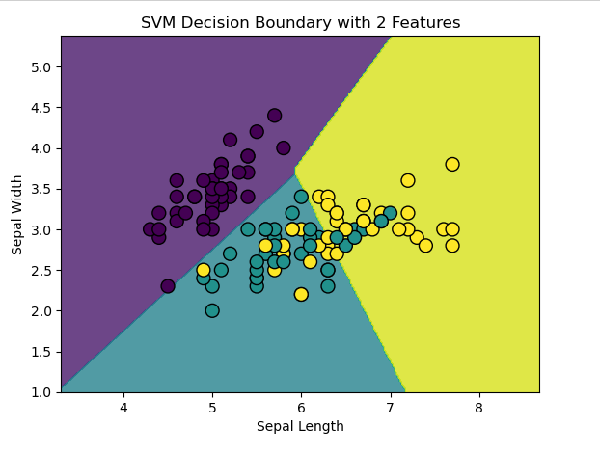

**Aim:[E]**

**Train a random forest ensemble. Experiment with the number of trees and feature sampling. Compare performance to a single decision tree.**

**CODE:**

# Import necessary libraries

import numpy as np

import pandas as pd

from sklearn.model_selection import train_test_split

from sklearn.tree import DecisionTreeClassifier

from sklearn.ensemble import RandomForestClassifier

from sklearn.metrics import accuracy_score

from sklearn.datasets import load_iris

# Load dataset (you can replace this with your own dataset)

iris = load_iris()

X = iris.data # Features

y = iris.target # Labels

# Split the data into training and testing sets (80% train, 20% test)

X_train, X_test, y_train, y_test = train_test_split(X, y, test_size=0.2, random_state=42)

# Step 1: Train a Decision Tree Classifier

dt_model = DecisionTreeClassifier(random_state=42)

dt_model.fit(X_train, y_train)

# Make predictions with the Decision Tree

y_pred_dt = dt_model.predict(X_test)

# Evaluate the Decision Tree

accuracy_dt = accuracy_score(y_test, y_pred_dt)

print(f"Decision Tree Accuracy: {accuracy_dt:.4f}")

# Step 2: Train a Random Forest Classifier with default parameters

rf_model_default = RandomForestClassifier(random_state=42)

rf_model_default.fit(X_train, y_train)

# Make predictions with the Random Forest (default)

y_pred_rf_default = rf_model_default.predict(X_test)

# Evaluate the Random Forest (default)

accuracy_rf_default = accuracy_score(y_test, y_pred_rf_default)

print(f"Random Forest (Default) Accuracy: {accuracy_rf_default:.4f}")

# Step 3: Train a Random Forest Classifier with custom parameters (more trees and feature sampling)

rf_model_custom = RandomForestClassifier(n_estimators=200, max_features='sqrt', random_state=42)

rf_model_custom.fit(X_train, y_train)

# Make predictions with the Random Forest (custom)

y_pred_rf_custom = rf_model_custom.predict(X_test)

# Evaluate the Random Forest (custom)

accuracy_rf_custom = accuracy_score(y_test, y_pred_rf_custom)

print(f"Random Forest (Custom) Accuracy: {accuracy_rf_custom:.4f}")

# Step 4: Compare the performance of the models

print("\nModel Comparison:")

print(f"Decision Tree Accuracy: {accuracy_dt:.4f}")

print(f"Random Forest (Default) Accuracy: {accuracy_rf_default:.4f}")

print(f"Random Forest (Custom) Accuracy: {accuracy_rf_custom:.4f}")

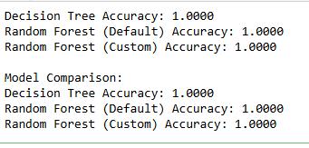

from sklearn.model_selection import cross_val_score

# Decision Tree with cross-validation

cv_scores_dt = cross_val_score(dt_model, X, y, cv=5) # 5-fold cross-validation

print(f"Decision Tree Cross-Validation Scores: {cv_scores_dt}")

print(f"Mean Cross-Validation Score (Decision Tree): {cv_scores_dt.mean():.4f}")

# Random Forest (default) with cross-validation

cv_scores_rf_default = cross_val_score(rf_model_default, X, y, cv=5)

print(f"Random Forest (Default) Cross-Validation Scores: {cv_scores_rf_default}")

print(f"Mean Cross-Validation Score (Random Forest Default): {cv_scores_rf_default.mean():.4f}")

# Random Forest (custom) with cross-validation

cv_scores_rf_custom = cross_val_score(rf_model_custom, X, y, cv=5)

print(f"Random Forest (Custom) Cross-Validation Scores: {cv_scores_rf_custom}")

print(f"Mean Cross-Validation Score (Random Forest Custom): {cv_scores_rf_custom.mean():.4f}")

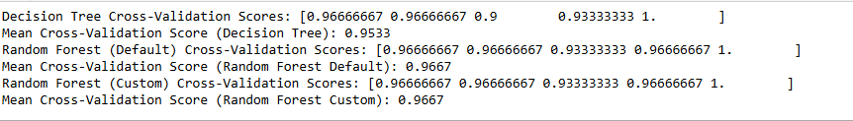

import matplotlib.pyplot as plt

from sklearn.tree import plot_tree

import numpy as np

# Column names (replace these with actual names in your dataset)

feature_names = ['sepal_length', 'sepal_width', 'petal_length', 'petal_width']

# Convert class labels to strings

class_names = [str(cls) for cls in np.unique(y_train)]

# Plot the decision tree

plt.figure(figsize=(20, 10))

plot_tree(dt_model, filled=True, feature_names=feature_names, class_names=class_names)

plt.show()

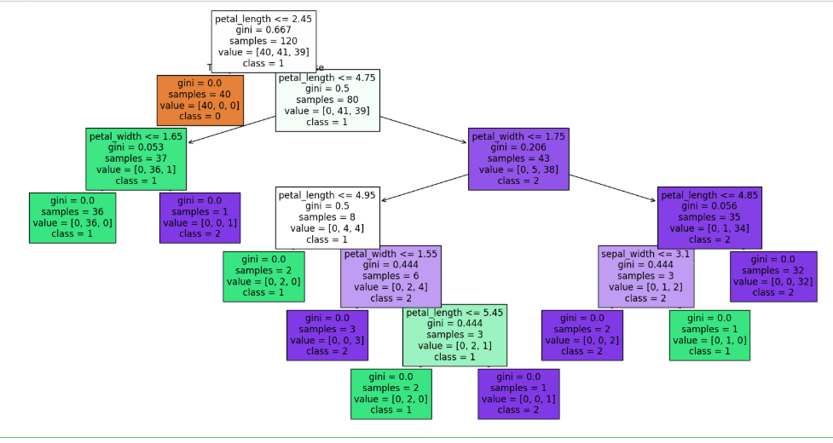

import pandas as pd

# If X is not a DataFrame, convert it to one and define the column names

X = pd.DataFrame(X, columns=['sepal_length', 'sepal_width', 'petal_length', 'petal_width'])

# Get feature importances from the trained Random Forest model

feature_importance = pd.Series(rf_model.feature_importances_, index=X.columns)

# Sort the feature importances in descending order

feature_importance = feature_importance.sort_values(ascending=False)

# Display the feature importances

print(feature_importance)

import matplotlib.pyplot as plt

# Plot the feature importances

plt.figure(figsize=(10, 6))

feature_importance.plot(kind='bar')

plt.title('Feature Importances - Random Forest')

plt.xlabel('Feature')

plt.ylabel('Importance')

plt.show()

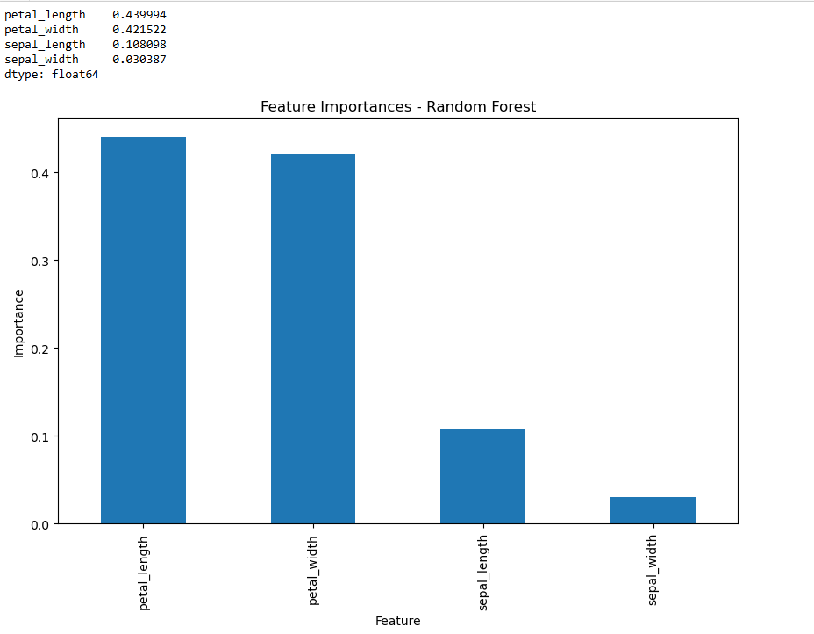

**PRACTICAL NO : 5**

**Generative Models**

**Aim:[A] Implement and demonstrate the working of a Naive Bayesian classifier using a sample data set. Build the model to classify a test sample.**

**CODE:**

# Import necessary libraries

import pandas as pd

from sklearn.model_selection import train_test_split

from sklearn.naive_bayes import GaussianNB

from sklearn.metrics import accuracy_score, classification_report

# Load the dataset from a CSV file

df = pd.read_csv("iris.csv") # Ensure the file is in the same directory or provide the correct path

# Separate features and target

X = df[['sepal_length', 'sepal_width', 'petal_length', 'petal_width']] # Feature columns

y = df['species'] # Target column (species)

# Encode the target column into integers

from sklearn.preprocessing import LabelEncoder

label_encoder = LabelEncoder()

y = label_encoder.fit_transform(y)

# Split dataset into training and testing sets

X_train, X_test, y_train, y_test = train_test_split(X, y, test_size=0.2, random_state=42)

# Create a Naive Bayes classifier (GaussianNB)

nb_model = GaussianNB()

# Train the model

nb_model.fit(X_train, y_train)

# Test the model on test data

y_pred = nb_model.predict(X_test)

# Evaluate the model

accuracy = accuracy_score(y_test, y_pred)

print(f"Accuracy: {accuracy:.4f}")

print("Classification Report:")

print(classification_report(y_test, y_pred, target_names=label_encoder.classes_))

# Classify a new test sample

test_sample = [[5.1, 3.5, 1.4, 0.2]] # Example sample resembling Setosa

prediction = nb_model.predict(test_sample)

predicted_class = label_encoder.inverse_transform(prediction)[0]

print(f"Prediction for test sample {test_sample}: {predicted_class}")

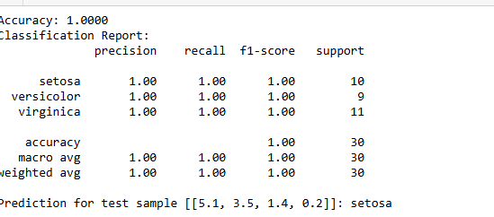

from sklearn.metrics import confusion_matrix

import seaborn as sns

import matplotlib.pyplot as plt

cm = confusion_matrix(y_test, y_pred)

sns.heatmap(cm, annot=True, fmt='d', cmap='Blues', xticklabels=label_encoder.classes_, yticklabels=label_encoder.classes_)

plt.xlabel('Predicted')

plt.ylabel('True')

plt.title('Confusion Matrix')

plt.show()

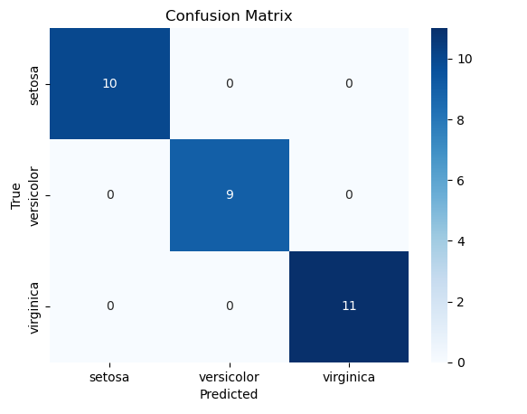

from sklearn.model_selection import cross_val_score

scores = cross_val_score(nb_model, X, y, cv=5) # 5-fold cross-validation

print(f"Cross-validation scores: {scores}")



**Aim:[B] Implement Hidden Markov Models using hmmlearn.**

**CODE:**

pip install hmmlearn

import numpy as np

from hmmlearn import hmm

import matplotlib.pyplot as plt

# Step 1: Generate synthetic data for the example

n_samples = 1000

n_features = 1 # univariate data (1 feature per observation)

# Create the model with 3 hidden states

model = hmm.GaussianHMM(n_components=3, covariance_type="diag", n_iter=1000)

# You need to first fit the model to some data before calling sample().

# You can use the same data to fit and then sample, or just fit a simple dataset.

X = np.random.randn(n_samples, n_features) # Use random data to fit (or use your own dataset)

# Step 2: Fit the model to the data

model.fit(X) # Fit the model first!

# Step 3: Now generate synthetic data using the model

# This can only be done after fitting the model

X_generated, Z_generated = model.sample(n_samples)

# Step 4: Predict the hidden states for each data point in the original data

hidden_states = model.predict(X) # Use predict to get the hidden states

# Step 5: Print the first few hidden states

print("First 10 hidden states:", hidden_states[:10])

# Step 6: Plot the observed data and hidden states

plt.figure(figsize=(15, 8))

# Plot the observations

plt.subplot(2, 1, 1)

plt.plot(X, label="Observed Data")

plt.title("Observed Data")

plt.xlabel("Time Steps")

plt.ylabel("Observation Value")

# Plot the hidden states

plt.subplot(2, 1, 2)

plt.plot(hidden_states, label="Hidden States", color='red')

plt.title("Hidden States")

plt.xlabel("Time Steps")

plt.ylabel("Hidden State")

plt.tight_layout()

plt.show()

# Step 7: Print the model's learned parameters

print("Means of each hidden state:", model.means_)

print("Covariances of each hidden state:", model.covars_)

print("Transition matrix:")

print(model.transmat_)

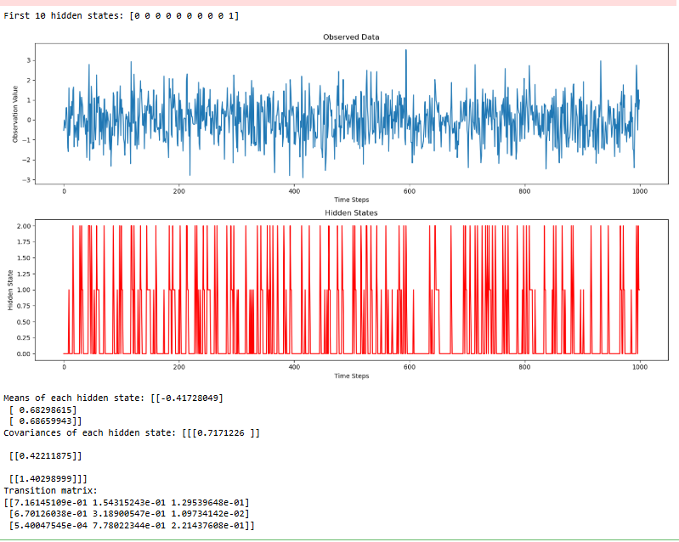

**PRACTICAL NO : 6**

**Probabilistic Models**

**Aim:[A] Implement Bayesian Linear Regression to explore prior and posterior distribution.**

**CODE:**

pip install pymc numpy scipy matplotlib seaborn arviz

import numpy as np

import matplotlib.pyplot as plt

import pymc as pm # Updated for PyMC v5

import seaborn as sns

import arviz as az # For better visualization of posterior distributions

from sklearn.linear_model import BayesianRidge

from sklearn.preprocessing import StandardScaler

# Set random seed for reproducibility

np.random.seed(42)

# Generate synthetic data

N = 50 # Number of data points

X = np.linspace(0, 10, N)[:, None] # Feature values

true_slope = 2.5

true_intercept = 1.0

noise = np.random.normal(0, 2, size=N) # Add Gaussian noise

y = true_slope * X.flatten() + true_intercept + noise # Linear relationship

# Bayesian Linear Regression with PyMC

with pm.Model() as model:

# Define priors for slope and intercept

alpha = pm.Normal("alpha", mu=0, sigma=10) # Intercept prior

beta = pm.Normal("beta", mu=0, sigma=10) # Slope prior

sigma = pm.HalfNormal("sigma", sigma=5) # Noise (observation standard deviation)

# Define the likelihood (observed data)

mu = alpha + beta * X.flatten()

y_obs = pm.Normal("y_obs", mu=mu, sigma=sigma, observed=y)

# Sample from the posterior using Markov Chain Monte Carlo (MCMC)

trace = pm.sample(2000, return_inferencedata=True, progressbar=True)

# Summary of posterior distributions

az.summary(trace)

# Plot posterior distributions

az.plot_posterior(trace, var_names=["alpha", "beta", "sigma"])

plt.show()

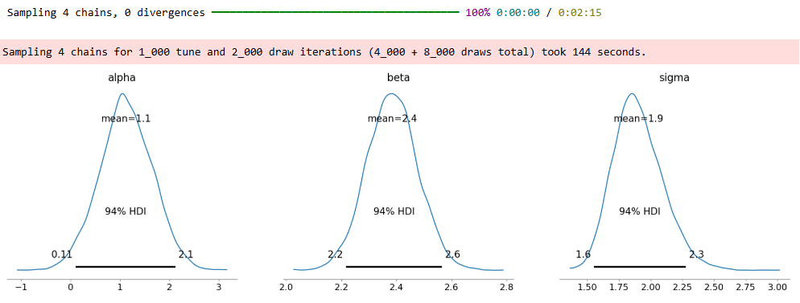

# Plot posterior distributions of alpha (intercept) and beta (slope)

sns.kdeplot(trace.posterior["alpha"].values.flatten(), label="Posterior of alpha (Intercept)", shade=True)

sns.kdeplot(trace.posterior["beta"].values.flatten(), label="Posterior of beta (Slope)", shade=True)

plt.axvline(true_intercept, color="red", linestyle="--", label="True Intercept")

plt.axvline(true_slope, color="blue", linestyle="--", label="True Slope")

plt.legend()

plt.title("Posterior Distributions of Parameters")

plt.show()

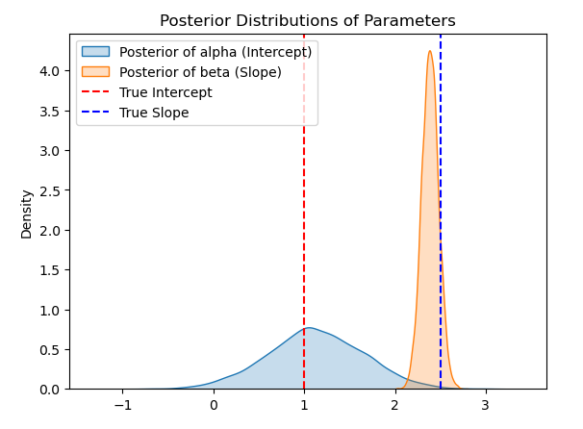

# Standardize features

scaler = StandardScaler()

X_scaled = scaler.fit_transform(X)

# Train Bayesian Ridge regression

bayesian_ridge = BayesianRidge()

bayesian_ridge.fit(X_scaled, y)

# Display learned parameters

print(f"Sklearn Bayesian Ridge: Intercept = {bayesian_ridge.intercept_:.3f}, Slope = {bayesian_ridge.coef_[0]:.3f}")



**Aim:[B] Implement Gaussian Mixture Models for density estimation and unsupervised clustering.**

**CODE:**

pip install numpy matplotlib seaborn scikit-learn

import numpy as np

import matplotlib.pyplot as plt

import seaborn as sns

from sklearn.mixture import GaussianMixture

from sklearn.datasets import make_blobs

# Set random seed for reproducibility

np.random.seed(42)

# Generate synthetic data (clusters)

X, _ = make_blobs(n_samples=300, centers=3, cluster_std=1.0, random_state=42)

# Fit a Gaussian Mixture Model (GMM)

n_components = 3 # Number of clusters

gmm = GaussianMixture(n_components=n_components, covariance_type='full', random_state=42)

gmm.fit(X)

# Predict cluster labels

labels = gmm.predict(X)

# Plot clusters

plt.figure(figsize=(8, 6))

sns.scatterplot(x=X[:, 0], y=X[:, 1], hue=labels, palette="viridis", s=50, edgecolor='k')

plt.scatter(gmm.means_[:, 0], gmm.means_[:, 1], c='red', marker='x', s=200, label='Centroids') # Cluster centers

plt.title("Gaussian Mixture Model Clustering")

plt.legend()

plt.show()

# Density Estimation (Plot Probability Contours)

x, y = np.meshgrid(np.linspace(X[:, 0].min(), X[:, 0].max(), 100),

np.linspace(X[:, 1].min(), X[:, 1].max(), 100))

X_grid = np.array([x.ravel(), y.ravel()]).T

log_probs = gmm.score_samples(X_grid).reshape(100, 100)

plt.figure(figsize=(8, 6))

plt.contourf(x, y, np.exp(log_probs), levels=30, cmap="Blues")

sns.scatterplot(x=X[:, 0], y=X[:, 1], hue=labels, palette="viridis", s=50, edgecolor='k')

plt.scatter(gmm.means_[:, 0], gmm.means_[:, 1], c='red', marker='x', s=200, label='Centroids')

plt.title("Gaussian Mixture Model - Density Estimation")

plt.legend()

plt.show()

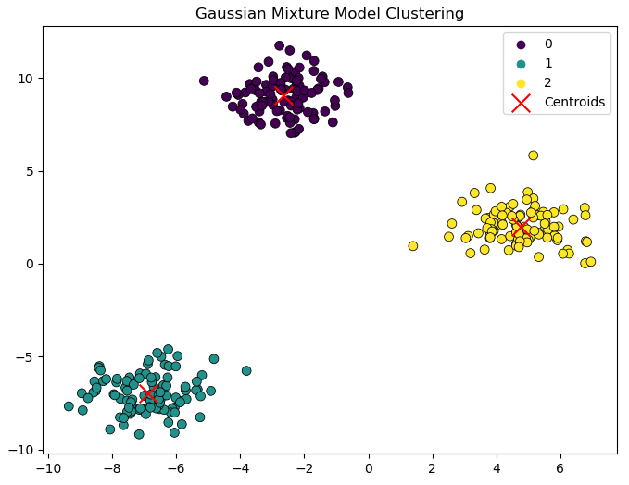

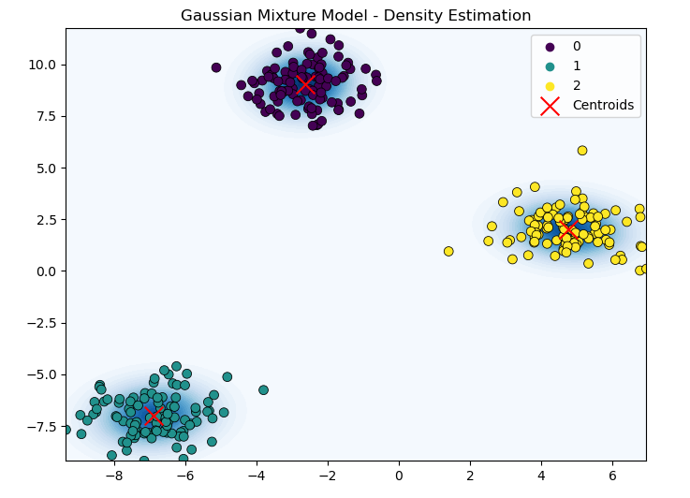

**PRACTICAL NO : 7**

**Model Evaluation and Hyperparameter Tuning**

**Aim:[A] Implement cross-validation techniques (k-fold, stratified, etc.) for robust model evaluation.**

**CODE:**